This guide describes how to track data changes in BOPF without any additional software installation (like BOPF Change Tracker).

In BOPF Test UI we have watch points functionality, dynamic break points for changes of special Node. You can re-use it for your Business application outside of BOPF Test UI. For that, you should activate standard Addon /BOBF/TOOL_DEBUG_ADDON and make some stuff in debugger.

Follow these instructions:

1. Open transaction se16 and create a record with Addon Name “/BOBF/TOOL_DEBUG_ADDON” for your user. Don`t ignore filling of field UNAME. Set SERV_MGR_ACTIVE and INT_ACCESS_ACTIVE as X (True). Leave BO_KEY with initial value or provide needed.
2. Open class /BOBF/CL_TOOL_DEBUG_ADDON, select method CONSTRUCTOR and set External breakpoint at the end of the method.
3. After that when you are starting any business application which is developed on BOPF, you will catch the breakpoint in Addon constructor.
4. In Variables tab choose GT_WATCHPOINT table. Double click and dive inside.

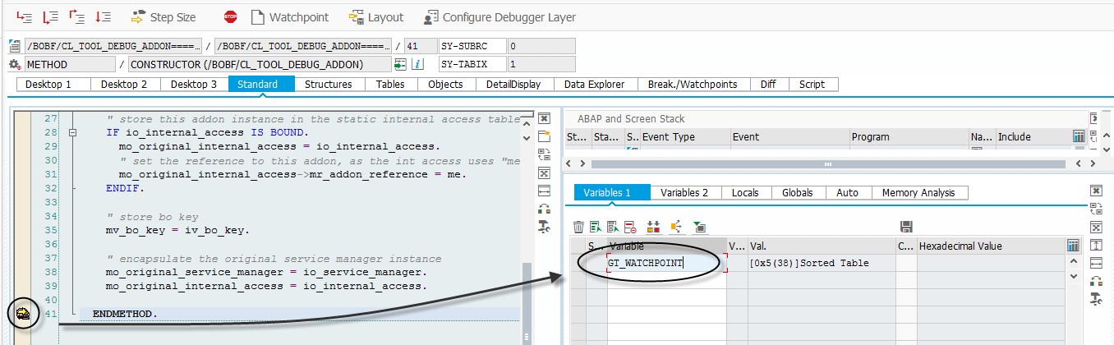 Select Change Table Content – Insert Row (using key).

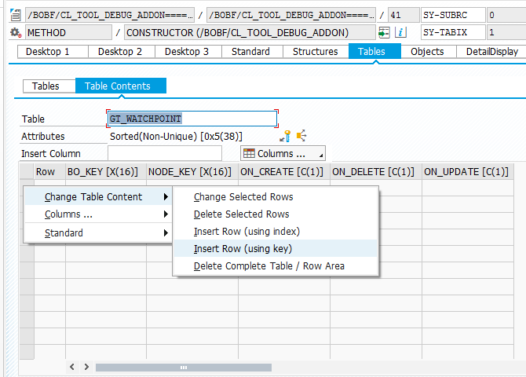

Fill new row with your BO_KEY and NODE_KEY. Select required change type (CREATE/DELETE/UPDATE).

As a result, watch point is activated for selected Node. Press F8 and investigate the code!

